**CENWP-OD-B 12 July 2024**

**MEMORANDUM FOR THE RECORD**

**SUBJECT: 24BON024 MFR CI LPS RB4 and RB5 Pacific Lamprey Mortality**

On the morning of 11 July, Project Biologists found one Pacific lamprey mortality in the Cascades Island LPS Rest Box 4 (CI LPS RB4) and one mortality in Rest Box 5 (CI LPS RB5). Both fish were scanned for PIT tags, measured, inspected, and returned to the river.

1) Rest Box 4

1. Species – Pacific Lamprey (*Entosphenus tridentatus*)
2. Origin – Unknown
3. Length – 62.87cm
4. Marks and tags – None
5. Marks and Injuries found on carcass – None
6. 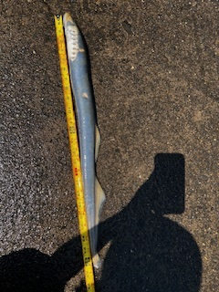Cause and Time of Death – Unknown
7. Future and Preventative Measures – N/A

2) Rest Box 5

1. Species – Pacific Lamprey (*Entosphenus tridentatus*)
2. Origin – Unknown
3. Length – 60.96cm
4. Marks and tags – None
5. Marks and Injuries found on carcass – None, except for part of caudal fin missing.
6. Cause and Time of Death – Unknown
7. Future and Preventative Measures – N/A

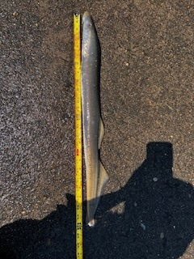

Sincerely,

Project Fisheries